**Buck Converter**

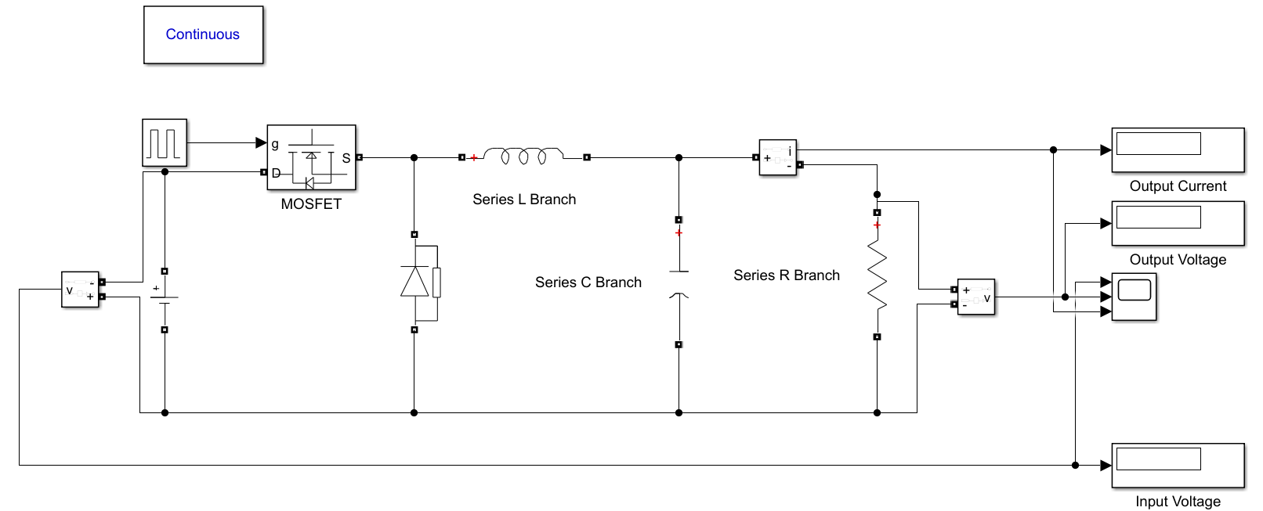

**Fig. Block Diagram of Buck Converter**



**Fig. Characteristics of Buck Converter**

**Boost Converter**

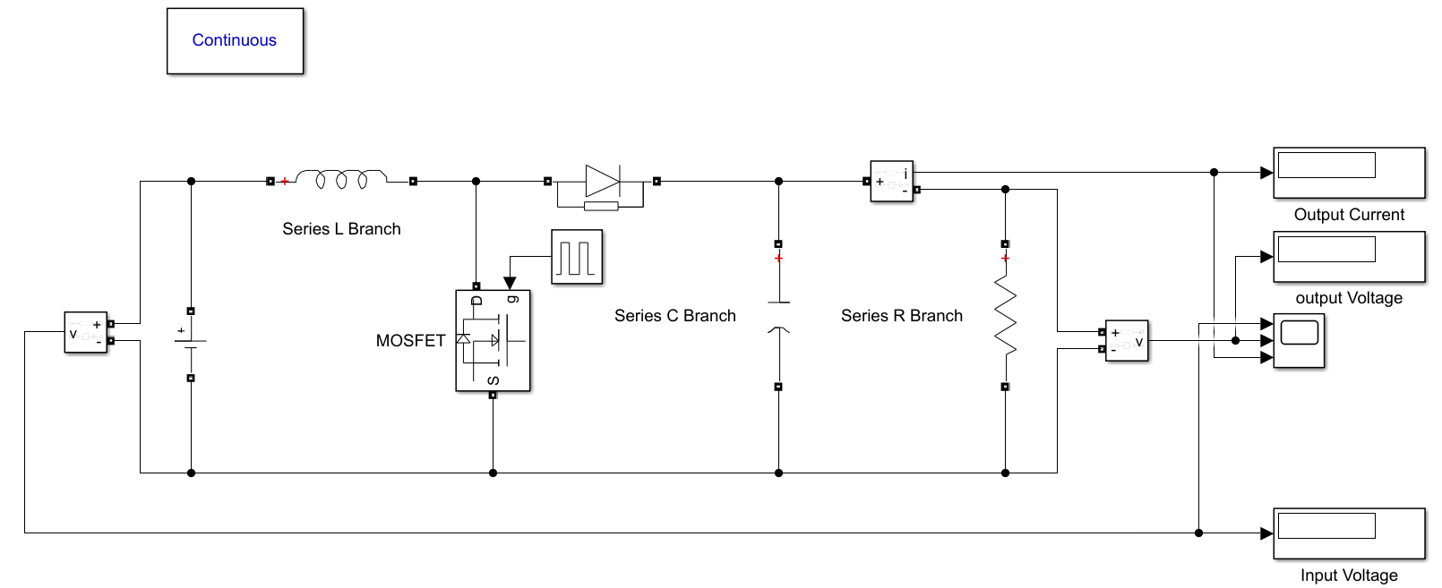

**Fig. Block Diagram of Boost Converter**



**Fig. Characteristics of Boost Converter**

**Buck-Boost Converter**

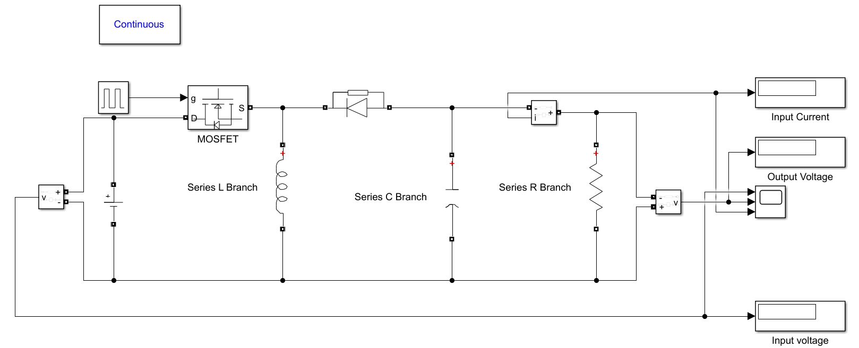

**Fig. Block Diagram of Buck-Boost Converter**



**Fig. Characteristics of Buck-Boost Converter**